A System Dynamics Model of the Refugee Crisis
Part 6: Optimization of the Model
Introduction
The Fortran program can be modified to conduct an optimization in which an output value can be maximized or minimized by changing the parameters. The optimization of the model will be conducted using a tool from artificial intelligence called a genetic algorithm. The parameters of the model are considered to be a vector of genes in a organism. The program starts with a random set of vectors representing a population of organisms. A subset of this population is assumed to survive based on the quality of their output. Then this fittest population will breed and produce offspring which are a mix of their genes (parameter values). There also will be the possibility that a small number of these offspring will have random mutations of their genes. Then the most well adapted offspring (those with the highest quality results) will form a new generation of the population. The program will stop once a goal is achieved or when a number of generations have been simulated.

We will vary the 26 parameters described in Part 5 of this report that the aid agencies have some control over and try to find a set of values that minimizes the cumulative avoidable deaths at the end of the five year period.

Results of the Optimization
The optimization process is one of diminishing returns. That is, the greatest amount of improvement is found in the first few iterations and as the number of iterations gets larger the relative improvements becomes less and less. The graph below is a typical run of 100,000 generations. The improvement goes from over 120,000 cumulative avoidable deaths in the five year period in the baseline run to approximately 20,000 cumulative avoidable deaths in the five year period after 40,000 generations of the genetic algorithm. This is followed by a further reduction to approximately 5,500 cumulative avoidable deaths over the five year period by the 100,000th generation.

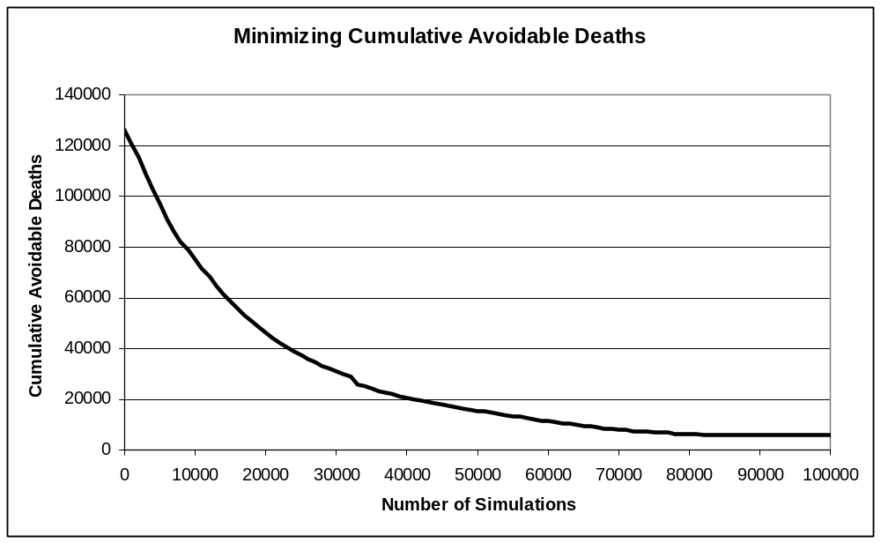

Table 1 shows the parameters that were used in the baseline run for the 26 variables that are under the control of the aid agencies along with the same parameters for the optimal run found using the genetic algorithm. We can see with slight changes to these controllable parameters, we could potentially save over 120,000 people's lives.

Table 1: Parameters of Baseline Run and Optimal Values Compared
VARIABLE NAME | BASELINE RUN | OPTIMAL VALUE
CUMULATIVE AVOIDABLE DEATHS | 126443.00 | 5544.46
NORMAL BORDER CONTROL RESOURCES | 10.00 | 4.48
NORMAL PEACEKEEPERS REQUIRED TO PROTECT SAFE HAVEN | 1000.00 | 421.71
NORMAL TIME TO CREATE A SAFE HAVEN | 24.00 | 3.59
NORMAL TOTAL INVESTMENT | 20.00 | 35.89
AVERAGE DIPLOMATS TO CREATE A CEASE FIRE | 10.00 | 1.87
AVERAGE PEACEKEEPERS TO REDUCE A BATTLE | 1000.00 | 648.41
AVERAGE PEOPLE A MEDICAL PRACTITIONER CAN HANDLE | 100.00 | 180.89
AVERAGE TIME TO CURE DISEASE | 2.00 | 1.06
AVERAGE TIME TO DEPLOY BORDER CONTROL RESOURCES | 6.00 | 3.51
AVERAGE TIME TO DEPLOY PEACEKEEPERS | 12.00 | 5.45
AVERAGE TIME TO EMPLOY DIPLOMATS | 6.00 | 4.78
AVERAGE TIME TO HIRE MEDICAL PRACTITIONER | 6.00 | 4.16
AVERAGE TIME TO PROCESS IMMIGRATION PAPERS | 12.00 | 3.69
AVERAGE TIME TO TRAIN IMMIGRATION OFFICERS | 12.00 | 5.43
FAMILIES PROCESSED AT SAME TIME BY IMMIGRATION OFFICER | 5.00 | 16.23
EFFECT OF BORDER CONTRL ON ATTEMPTED BORDER CROSSINGS PER MONTH | 1.00 | 0.46
EFFECT OF DEATHS PER MONTH ON FRACTION OF INVESTMENT IN BORDER CONTROL | 1.00 | 0.47
EFFECT OF DEATHS PER MONTH ON TOTAL INVESTMENT | 1.00 | 0.48
EFFECT OF DISEASE ON FRACTION OF INVESTMENT ON HEALTH SERVICES | 0.20 | 0.11
EFFECT OF FAMINE ON FRACTION OF INVESTMENT IN FOOD AID | 0.20 | 0.02
EFFECT OF PEACEKEEPERS ON TIME TO CREATE SAFE HAVEN | 1.00 | 0.39
EFFECT OF PEOPLE IN DANGER ON TOTAL INVESTMENT | 0.10 | 0.06
EFFECT OF REFUGEES ON FRACTION OF INVESTMENT IN IMMIGRATION | 10.00 | 3.31
EFFECT OF VIOLENCE ON DISTRIBUTION OF FOOD AID | 1.00 | 3.81
EFFECT OF VIOLENCE ON FRACTION OF INVESTMENT ON DIPLOMACY | 0.20 | 0.03
EFFECT OF VIOLENCE ON FRACTION OF INVESTMENT IN PEACEKEEPING | 0.40 | 0.12

There is a random element in the genetic algorithm so we ran the algorithm a number of times and compared the results. After 100,000 generations, the results in terms of cumulative avoidable deaths was always around 5,500 no matter what the random number generator seed was. Also the parameter values were approximately the same no matter what the random number generator seed was. So we believe we have a robust solution to the refugee crisis.

The massive reduction in cumulative avoidable deaths is created by changes in all of the parameters under the control of the aid agencies because they are all highly connected. Going from the top to the bottom of this table, we see that the border control resources would need to be used more efficiently reducing the normal border resources from the baseline value of 10 to less than 5. Similarly, the peacekeepers required to protect a safe haven would need to be used more efficiently and thereby reduced from 1000 to less than 500. The time to create a safe haven would need to be reduced from 24 months to less than 4 months to reach the optimal results. The normal total investment would need to be increased from 20 million dollars per month to over 35 million dollars per month.

The diplomatic service would need to be more effective with the average diplomats to create a cease fire reduced from 10 to 2 and the average peacekeepers would need to be more effective at reducing battles with the average peacekeepers required to reduce a battle declining from 1000 to 650 soldiers. We will also need to improve the effectiveness of the peacekeepers in creating safe havens by reducing the mid-point of the effect function from 1 to 0.4. Medical practitioners would have to be more effective as well with increased capability to handle patients simultaneously increasing from 100 to 180 and the average time to cure disease reduced from 2 months to 1 month.

The reaction times would need to all be reduced. The average time to deploy border control resources would need to be reduced from 6 months to 3.5 months. The average time to deploy peacekeepers would need to be reduced from 12 months to 5.5 months. The average time to employ diplomats would need to reduced from 6 months to 4.75 months. The average time to hire medical practitioners would need to be reduced from 6 months to 4 months. The average time train immigration officers would need to be reduced from 12 months to 5.5 months and the immigration officers would need to be more efficient reducing their average time to process immigration papers from 12 months to 3.5 months and increasing the number of families they process at the same time from 5 to 16.

Then we would need to improve the effectiveness of border control by reducing the effect function mid-point from 1 to 0.5 and making the responsiveness of the number of deaths per month from unsuccessful border crossings to investment in border control improve by dropping the mid-point of the effect function from 1 to 0.5. We would need to improve the responsiveness of the total aid investment to the average avoidable deaths per month by reducing the effect function mid-point from 1 to 0.5. We would need to improve the responsiveness of the health services investment process by reducing the effect mid-point from 0.2 to 0.1. And improve the responsiveness to famine by reducing the mid-point from 0.2 to 0.02. We need to improve the effectiveness of peacekeepers at creating safe havens by reducing the effect of time to create a safe haven mid-point from 1 to 0.4.

We need to be more responsive to the number of people in danger by reducing the mid-point of the effect function from 0.1 to 0.06 and improve the responsiveness of immigration on the number of refugees by reducing the mid-point of the effect function from 10 to 3. We need to improve the responsiveness of food aid distribution to the level of violence by increasing the effect function mid-point from 1 to 4. And improve the responsiveness to violence in the investment in diplomacy and peacekeeping by decreasing the mid-point values from 0.2 to 0.03 and from 0.4 to 0.1 respectively.
The graphs below show the final result of the genetic algorithm compared to the results of the baseline run.

Results of the Optimization
The first graph shows the small number of cumulative avoidable deaths in the optimal run compared to the baseline run.
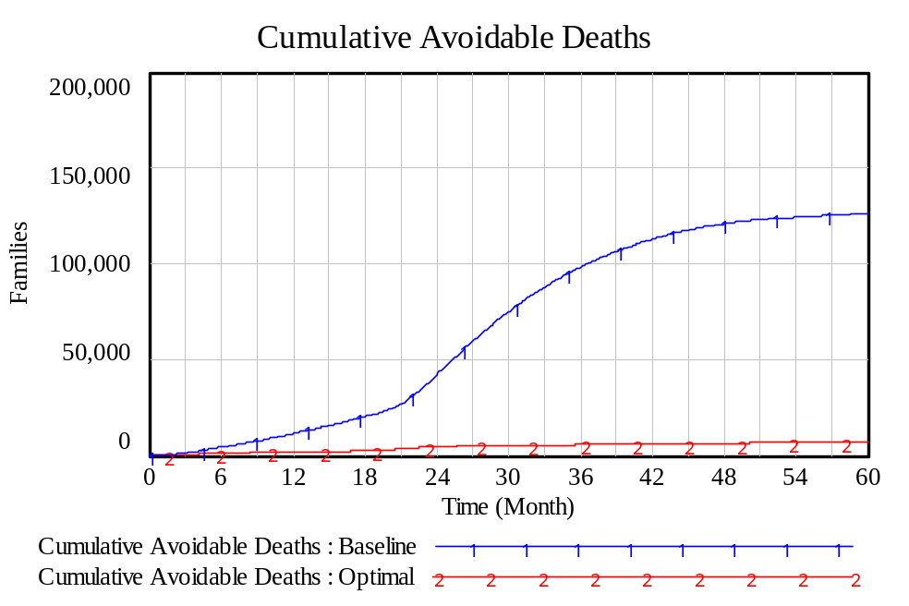
Graph 1
We can see from the second graph that the total investment over the period of five years is not that much different between the baseline run and the optimal run. The difference obviously is that the investment in aid is more efficiently used in the optimal run.
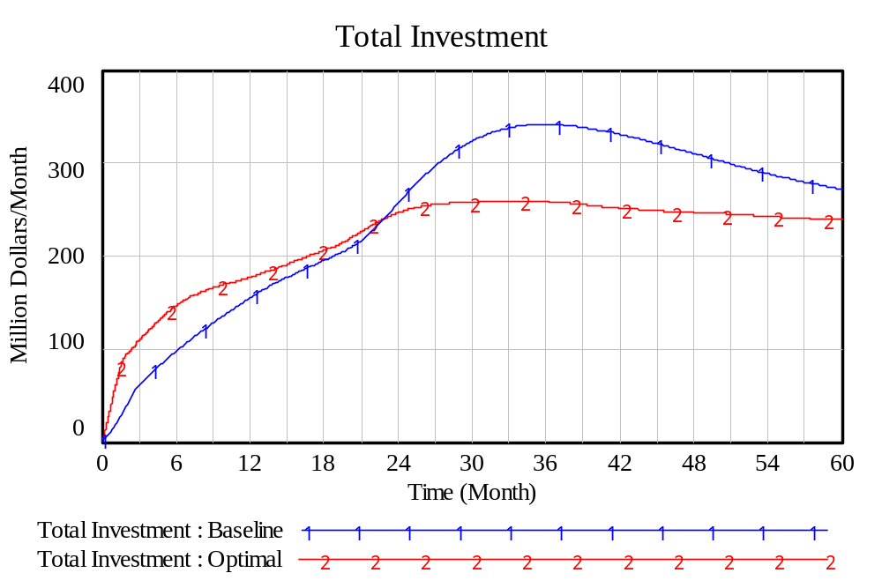
Graph 2
We can see from third graph that the number of people who stay in the foreign country is higher in the optimal run compared to the baseline run. This is probably because there are more safe havens in the optimal run than in the baseline run as shown in the fourth graph.

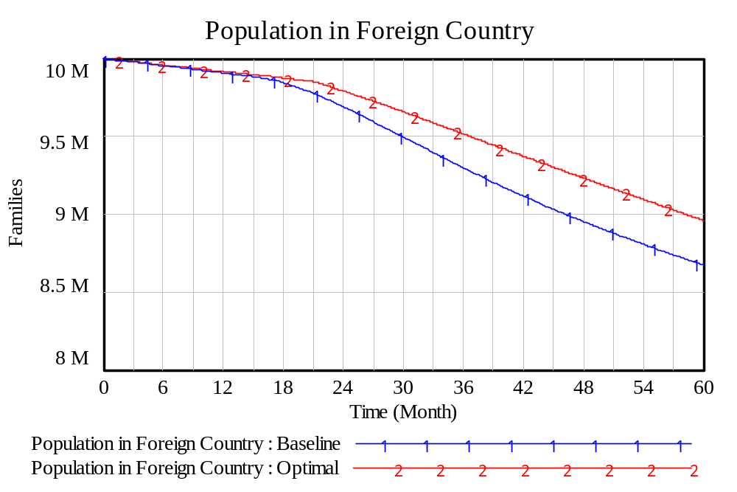
Graph 3
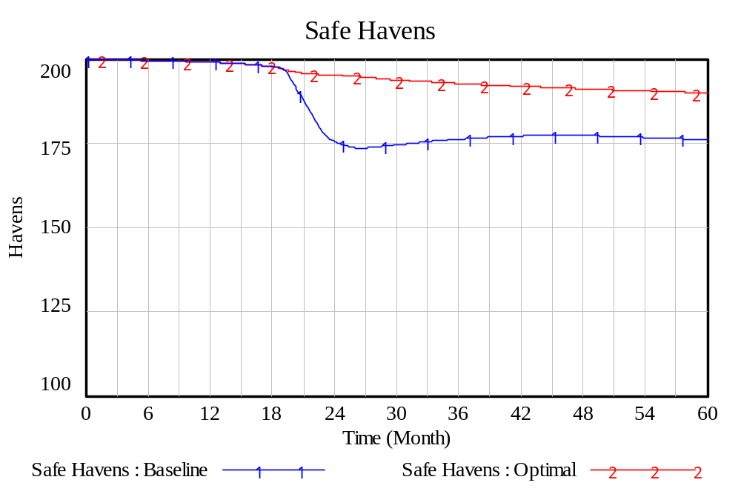
Graph 4
We can see that the avoidable deaths per month are an order of magnitude lower in the optimal case compared to the baseline case as shown in the fifth and sixth graphs.
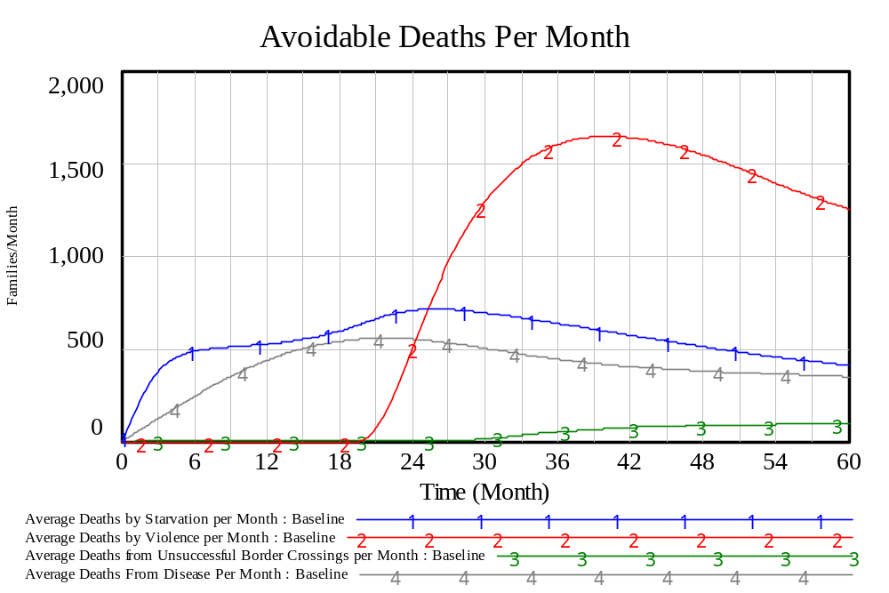
Graph 5
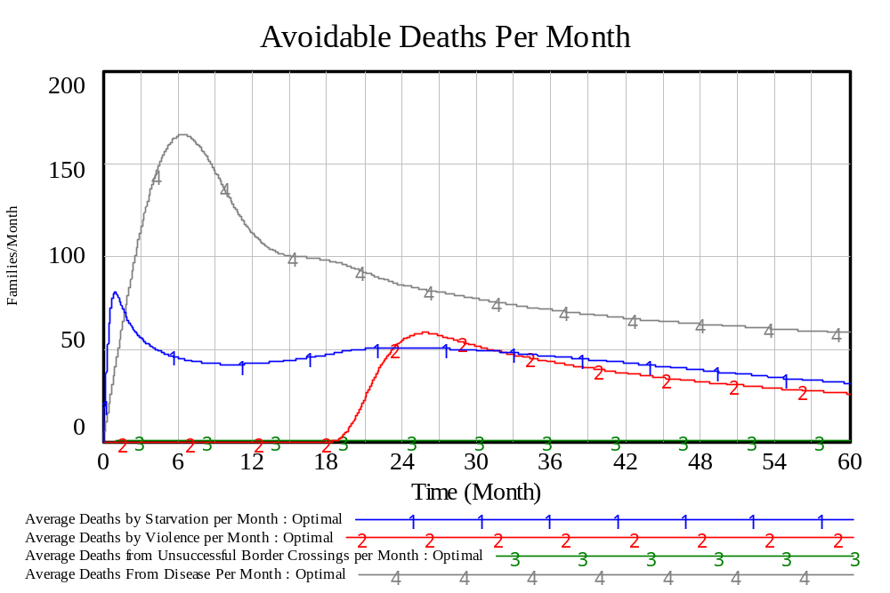
Graph 6
The short-term investment in aid seems to be much lower per month in the optimal case
compared to the baseline case as shown in the seventh and eighth graphs.
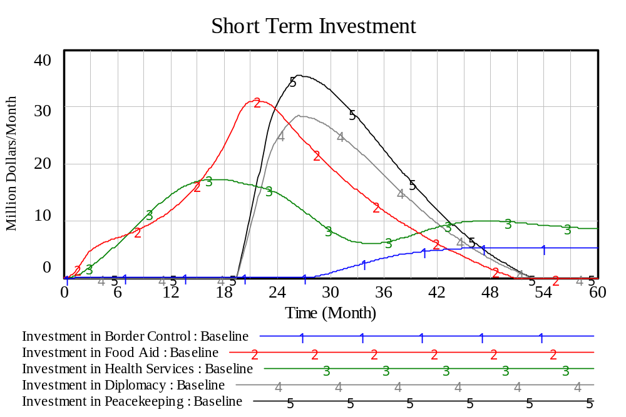
Graph 7
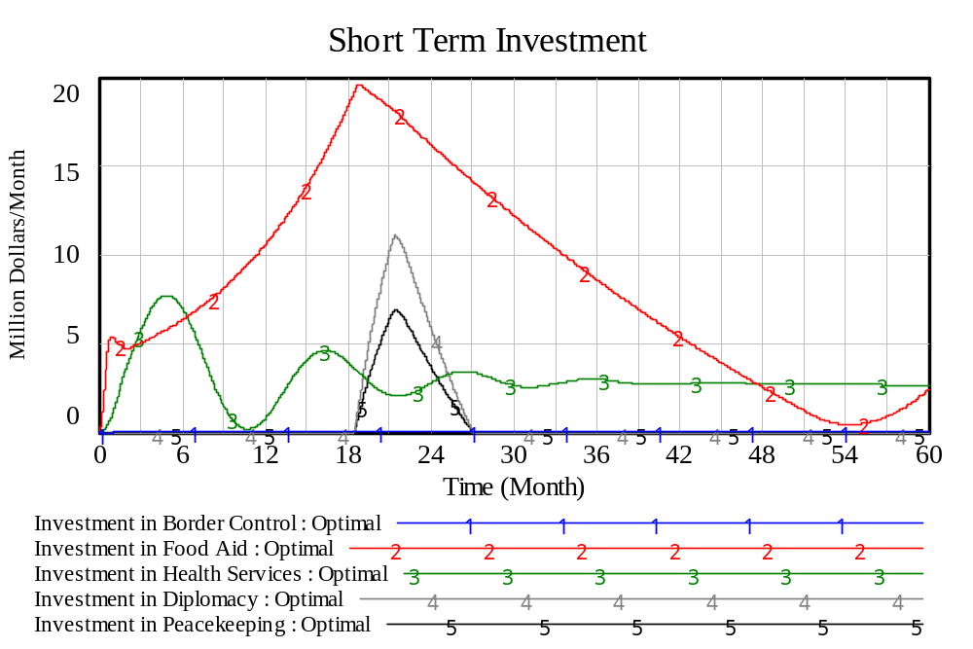
Graph 8
The long-term investment in immigration and economic development do not appear to be
very different as can be seen from the ninth and tenth graphs.
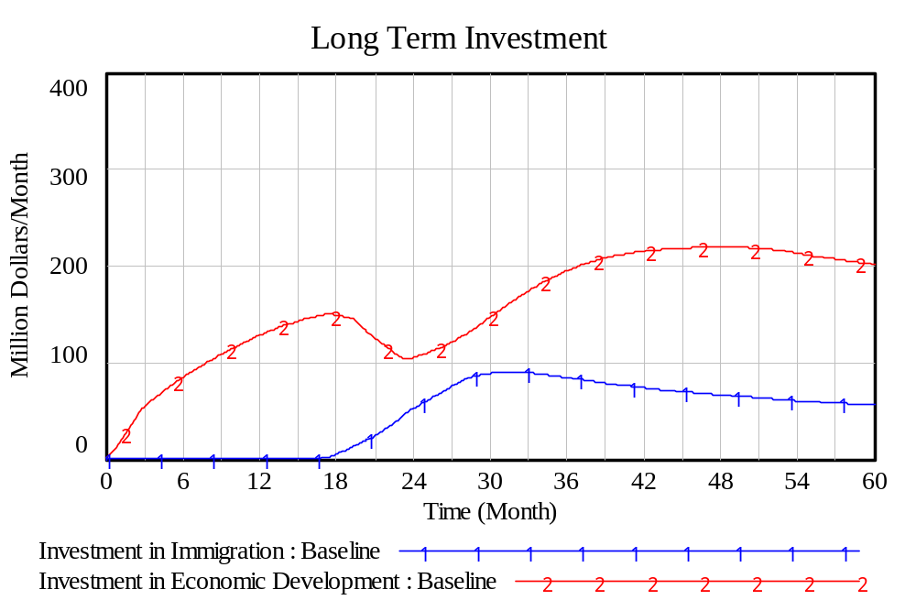
Graph 9
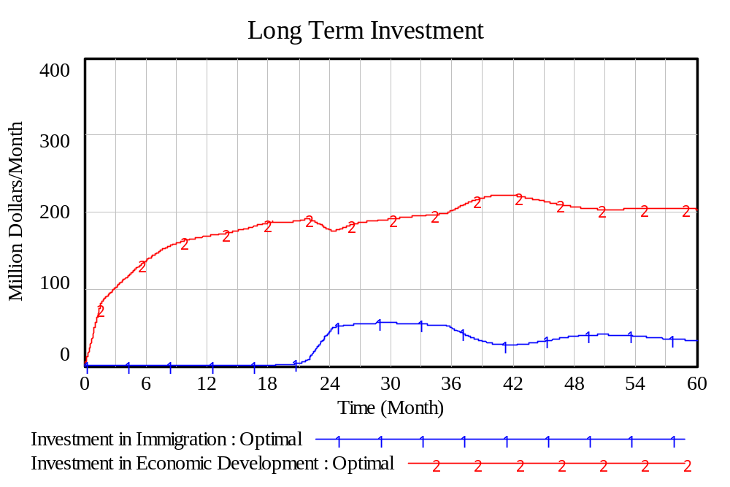
Graph 10

The Annexes
In Annex A, the main program of the genetic algorithm optimization program is provided. In Annex B, the subroutine that generates the initial starting population is provided. In Annex C, the subroutine that conducts the gene mutation is provided. In Annex D, the subroutine that converts the genes of the organism into the parameters for the simulation run is provided. In Annex E, the subroutine that sorts the population into the most fit to least fit is provided. In Annex F, the subroutine that generates the next generation of the population is provided.

Summary and Conclusion
In Part 1 of this report, we introduced the concept of System Dynamics modeling that we felt would be useful for modeling the refugee crisis in Northern Africa. We developed a System Dynamics simulation of the refugee crisis based on a series of Influence Diagrams. The Influence Diagrams were documented in Part 2 of this report. To run this simulation, we needed to estimate more than 100 parameters. We did this is in rough manner to obtain a baseline run. The philosophy of System Dynamics modeling is that one should estimate the parameters of the model in a rough manner rather than ignore the factor altogether. A prototype System Dynamics model was developed in the special-purpose language Vensim. This was useful for testing the concepts and documenting the sub-models in stock and flow diagrams and equations in English language expressions. This was documented in Part 3 of this report. Then the model was converted to the general-purpose programming language Fortran and tested against the Vensim version of the model. The Fortran version of the model was documented in Part 4 of this report. The Fortran version of the model was useful for conducting sensitivity analysis on the parameters. The detailed sensitivity analysis of the parameters allowed us to determine which parameters needed to be estimated with greater care to produce accurate projections of the number of avoidable deaths and which were less important in the model. This sensitivity analysis was conducted using a technique from statistical analysis called design of experiments. We found that a subset of 24 variables were the most important to estimate accurately while the remaining 74 variables could be estimated in a rough manner because they had less impact of the model projections. This sensitivity analysis is documented in Part 5 of this report. Finally, we were able to optimize the model to minimize the number of avoidable deaths over the five year period of study by varying the parameters under the control of the aid agencies. We found that by using information on the crisis for a rapid response in terms of aid and by using this aid in a highly effective manner, there is the potential to save many thousands of lives.
ANNEX A
The Main Program of the Genetic Algorithm Optimization
The code below shows the main program that controls the genetic algorithm optimization. The usual commands open the program. There are three output files identified: OPTIMAL.OUT for the best set of parameters found by the algorithm, OPTPATH.OUT to store the progress of search process in the algorithm, and RESULTS.OUT where the results of the run with the best set of parameters is stored.

The population of 90 organisms are defined in the array POP(90,27). The element POP(I,1) stores the value of the cumulative avoidable deaths for the run using the series of 26 parameters running from POP(I,2) to POP(I,27).

C234567*****************************************************************
C
C REFUGEE CRISIS SYSTEM DYNAMICS MODEL
C
C THIS VERSION OF THE REFUGEE CRISIS MODEL WILL ATTEMPT TO MINIMIZE
C THE CUMULATIVE AVOIDABLE DEATHS BY VARYING THE 27 PARAMETERS
C UNDER THE CONTROL OF THE AID AGENCIES.
C TO DO THIS, A GENETIC ALGORITHM IS USED.

IMPLICIT DOUBLE PRECISION (A-H, O-Z)

INCLUDE 'COMVAR.DCL'

REAL*8 POP(90,27)

OPEN(1,FILE='R-RUNCONT.DAT')
OPEN(2,FILE='R-INITIALS.DAT')
OPEN(3,FILE='R-NORMALS.DAT')
OPEN(4,FILE='R-CONSTANTS.DAT')
OPEN(5,FILE='R-EFFECTS.DAT')
OPEN(7,FILE='OPTIMAL.OUT')
OPEN(8,FILE='OPTPATH.OUT')
OPEN(9,FILE='RESULTS.OUT')

CALL READRUNP
CALL READINIT
CALL READNORM
CALL READCONS
CALL READETAB

CALL SRAND(ISEED)

C NFLAG SET TO 0 TO START AND SET TO 1 AT END OF
C PROGRAM TO PRINT RESULTS FROM OPTIMAL SET OF
C PARAMETERS

NFLAG = 0

C OLDCAD SET TO A HIGH VALUE TO START OPTIMIZATION
C PROCESS AND UPDATED AS BETTER RESULTS ARE FOUND

OLDCAD = 1.0E16

C NREPS KEEPS TRACK OF THE NUMBER OF GENERATIONS

NREPS = 0

C ORIGINALLY THE NEW MEMBER OF THE NEXT GENERATION
C IS SET TO BE THE SAME AT ONE OF THE PARENTS
C THEN SWITCH IS THE PROBABILITY OF A GENE BEING
C SWITCHED WITH THE OTHER PARENT

SWITCH = 0.5

C XMUTATE IS THE PROBABILITY THAT A GENE WILL MUTATE
C IN THE NEXT GENERATION

XMUTATE = 0.001

CALL RANDPOP(POP)

C START GENETIC ALGORITHM AND RUN FOR NITER GENERATIONS

4 IF (NREPS .GT. NITER) GO TO 50

NREPS = NREPS + 1

IF (NREPS .GT. 1) THEN
CALL NEXTGEN(POP,SWITCH,XMUTATE)
ENDIF

DO 40 I = 1,90
CALL CONVERT(I,POP)
CALL RUNSIM(CAD,NFLAG)
POP(I,1) = CAD

40 CONTINUE

CALL SORTPOP(POP)

IF (POP(1,1) .LT. OLDCAD) THEN
OLDCAD = POP(1,1)
PRINT*,NREPS,OLDCAD
ENDIF

IF ((FLOAT(NREPS)/1000.0 - INT(NREPS/1000)) .LE. 0.0001
1 .OR. NREPS .EQ. 1) THEN
WRITE(8,*) NREPS,OLDCAD
ENDIF

GO TO 4

50 CONTINUE

DO 60 J = 1,27
WRITE(7,*) J-1,POP(1,J)
60 CONTINUE

CALL CONVERT(1,POP)

NFLAG = 1

CALL RUNSIM(CAD,NFLAG)

STOP
END

ANNEX B
The Subroutine to Generate the Initial Population
This subroutine generates the initial population of 90 organisms by using the mutation subroutine on the baseline values for the 26 parameters that the aid agencies can control.

C***********************************************************************
C THIS SUBROUTINE GENERATES THE STARTING POPULATION OF 90 MEMBERS
C RANDOMLY BY MUTATING THE BASELINE VALUES OF THE GENES OF EACH
C MEMBER OF THE POPULATION.
C
SUBROUTINE RANDPOP(POP)

IMPLICIT DOUBLE PRECISION (A-H, O-Z)

INCLUDE 'COMVAR.DCL'

REAL*8 POP(90,27)

C SET PARAMETERS RANDOMLY FOR INITIAL SIMULATION RUN
C
C 02 NORMAL BORDER CONTROL RESOURCES
C 03 NORMAL PEACEKEEPERS REQUIRED TO PROTECT SAFE HAVEN
C 04 NORMAL TIME TO CREATE A SAFE HAVEN
C 05 NORMAL TOTAL INVESTMENT
C 06 AVERAGE DIPLOMATS TO CREATE A CEASE FIRE
C 07 AVERAGE PEACEKEEPERS TO REDUCE A BATTLE
C 08 AVERAGE PEOPLE A MEDICAL PRACTITIONER CAN HANDLE
C 09 AVERAGE TIME TO CURE DISEASE
C 10 AVERAGE TIME TO DEPLOY BORDER CONTROL RESOURCES
C 11 AVERAGE TIME TO DEPLOY PEACEKEEPERS
C 12 AVERAGE TIME TO EMPLOY DIPLOMATS
C 13 AVERAGE TIME TO HIRE MEDICAL PRACTITIONER
C 14 AVERAGE TIME TO PROCESS IMMIGRATION PAPERS
C 15 AVERAGE TIME TO TRAIN IMMIGRATION OFFICERS
C 16 FAMILIES PROCESSED AT SAME TIME BY IMMIGRATION OFFICER
C 17 EFFECT OF BORDER CONTRL ON ATTEMPTED BORDER CROSSINGS
C PER MONTH
C 18 EFFECT OF DEATHS PER MONTH ON FRACTION OF INVESTMENT IN
C BORDER CONTROL
C 19 EFFECT OF DEATHS PER MONTH ON TOTAL INVESTMENT
C 20 EFFECT OF DISEASE ON FRACTION OF INVESTMENT ON HEALTH
C SERVICES
C 21 EFFECT OF FAMINE ON FRACTION OF INVESTMENT IN FOOD AID
C 22 EFFECT OF PEACEKEEPERS ON TIME TO CREATE SAFE HAVEN
C 23 EFFECT OF PEOPLE IN DANGER ON TOTAL INVESTMENT
C 24 EFFECT OF REFUGEES ON FRACTION OF INVESTMENT IN
C IMMIGRATION
C 25 EFFECT OF VIOLENCE ON DISTRIBUTION OF FOOD AID
C 26 EFFECT OF VIOLENCE ON FRACTION OF INVESTMENT ON
C DIPLOMACY
C 27 EFFECT OF VIOLENCE ON FRACTION OF INVESTMENT IN
C PEACEKEEPING

DO 10 I = 1,90

POP(I,2) = AMUTATE(YBCNR)
POP(I,3) = AMUTATE(YPRSH)
POP(I,4) = AMUTATE(YTCSH)
POP(I,5) = AMUTATE(YTI)
POP(I,6) = AMUTATE(ADCCF)
POP(I,7) = AMUTATE(APRB)
POP(I,8) = AMUTATE(APMP)
POP(I,9) = AMUTATE(ATCD)
POP(I,10) = AMUTATE(ATDBCR)
POP(I,11) = AMUTATE(ATDP)
POP(I,12) = AMUTATE(ATED)
POP(I,13) = AMUTATE(ATHMP)
POP(I,14) = AMUTATE(ATPIP)
POP(I,15) = AMUTATE(ATTIO)
POP(I,16) = AMUTATE(FPIO)
POP(I,17) = AMUTATE(EBCRABT(2,1))
POP(I,18) = AMUTATE(EDFIBCT(2,1))
POP(I,19) = AMUTATE(EDPMTIT(2,1))
POP(I,20) = AMUTATE(EDFIHST(2,1))
POP(I,21) = AMUTATE(EFFIFAT(2,1))
POP(I,22) = AMUTATE(EPTCSHT(2,1))
POP(I,23) = AMUTATE(EPDOTIT(2,1))
POP(I,24) = AMUTATE(ERFIIIT(2,1))
POP(I,25) = AMUTATE(EVODFAT(2,1))
POP(I,26) = AMUTATE(EVFIDPT(2,1))
POP(I,27) = AMUTATE(EVFIPKT(2,1))

10 CONTINUE

RETURN
END

ANNEX C
The Function that Conducts the Random Mutation of Genes
This function does a slight random mutation of the gene (parameter) that is sent to the subroutine.

C***********************************************************************
C THIS SUBROUTINE MUTATES THE GENE RANDOMLY BY CHANGING THE VALUE OF
C THE GENE SLIGHTLY EITHER UP OR DOWN.
C
FUNCTION AMUTATE(GENE)

IMPLICIT DOUBLE PRECISION (A-H, O-Z)

IF (RAND() .LT. 0.5) THEN
AMUTATE = GENE * 0.999
ELSE
AMUTATE = GENE * 1.001
ENDIF

RETURN
END

ANNEX D
The Subroutine that Converts the Organism Genes into Parameters for the Simulation
This subroutine converts the values for organism I of the population to the parameters of the simulation that the aid agencies can control.

C***********************************************************************
C THIS SUBROUTINE CONVERTS THE VALUES STORED IN THE POP ARRAY INTO
C THE VALUES NEEDED TO RUN THE SIMULATION.
C
SUBROUTINE CONVERT(I,POP)

IMPLICIT DOUBLE PRECISION (A-H, O-Z)

INCLUDE 'COMVAR.DCL'

REAL*8 POP(90,27)

C CONVERT PARAMETERS FOR SIMULATION RUN
C

C SET PARAMETERS RANDOMLY FOR INITIAL SIMULATION RUN
C
C 02 NORMAL BORDER CONTROL RESOURCES
C 03 NORMAL PEACEKEEPERS REQUIRED TO PROTECT SAFE HAVEN
C 04 NORMAL TIME TO CREATE A SAFE HAVEN
C 05 NORMAL TOTAL INVESTMENT
C 06 AVERAGE DIPLOMATS TO CREATE A CEASE FIRE
C 07 AVERAGE PEACEKEEPERS TO REDUCE A BATTLE
C 08 AVERAGE PEOPLE A MEDICAL PRACTITIONER CAN HANDLE
C 09 AVERAGE TIME TO CURE DISEASE
C 10 AVERAGE TIME TO DEPLOY BORDER CONTROL RESOURCES
C 11 AVERAGE TIME TO DEPLOY PEACEKEEPERS
C 12 AVERAGE TIME TO EMPLOY DIPLOMATS
C 13 AVERAGE TIME TO HIRE MEDICAL PRACTITIONER
C 14 AVERAGE TIME TO PROCESS IMMIGRATION PAPERS
C 15 AVERAGE TIME TO TRAIN IMMIGRATION OFFICERS
C 16 FAMILIES PROCESSED AT SAME TIME BY IMMIGRATION OFFICER
C 17 EFFECT OF BORDER CONTRL ON ATTEMPTED BORDER CROSSINGS
C PER MONTH
C 18 EFFECT OF DEATHS PER MONTH ON FRACTION OF INVESTMENT IN
C BORDER CONTROL
C 19 EFFECT OF DEATHS PER MONTH ON TOTAL INVESTMENT
C 20 EFFECT OF DISEASE ON FRACTION OF INVESTMENT ON HEALTH
C SERVICES
C 21 EFFECT OF FAMINE ON FRACTION OF INVESTMENT IN FOOD AID
C 22 EFFECT OF PEACEKEEPERS ON TIME TO CREATE SAFE HAVEN
C 23 EFFECT OF PEOPLE IN DANGER ON TOTAL INVESTMENT
C 24 EFFECT OF REFUGEES ON FRACTION OF INVESTMENT IN
C IMMIGRATION
C 25 EFFECT OF VIOLENCE ON DISTRIBUTION OF FOOD AID
C 26 EFFECT OF VIOLENCE ON FRACTION OF INVESTMENT ON
C DIPLOMACY
C 27 EFFECT OF VIOLENCE ON FRACTION OF INVESTMENT IN
C PEACEKEEPING

YBCNR = POP(I,2)
YPRSH = POP(I,3)
YTCSH = POP(I,4)
YTI = POP(I,5)
ADCCF = POP(I,6)
APRB = POP(I,7)
APMP = POP(I,8)
ATCD = POP(I,9)
ATDBCR = POP(I,10)
ATDP = POP(I,11)
ATED = POP(I,12)
ATHMP = POP(I,13)
ATPIP = POP(I,14)
ATTIO = POP(I,15)
FPIO = POP(I,16)
EBCRABT(2,1) = POP(I,17)
EDFIBCT(2,1) = POP(I,18)
EDPMTIT(2,1) = POP(I,19)
EDFIHST(2,1) = POP(I,20)
EFFIFAT(2,1) = POP(I,21)
EPTCSHT(2,1) = POP(I,22)
EPDOTIT(2,1) = POP(I,23)
ERFIIIT(2,1) = POP(I,24)
EVODFAT(2,1) = POP(I,25)
EVFIDPT(2,1) = POP(I,26)
EVFIPKT(2,1) = POP(I,27)

RETURN
END
ANNEX E
The Subroutine to Find the Most Fit Organism of the Population
This is a simple exchange sort that sorts the population into the most fit (least cumulative avoidable deaths) to least fit (most cumulative avoidable deaths). The cumulative avoidable deaths is stored in POP(I,1).

C***********************************************************************
C THIS SUBROUTINE SORTS THE POPULATION BY THE CUMULATIVE AVOIDABLE
C DEATHS WHICH IS SAVED AS POP(I,1) FOR THE 90 MEMBERS OF THE
C POPULATION. THEREFORE, POP(1,1) REPRESENTS THE BEST RESULT FOUND
C SO FAR BY THE ALGORITHM.
C
SUBROUTINE SORTPOP(POP)

IMPLICIT DOUBLE PRECISION (A-H, O-Z)

REAL*8 POP(90,27)

5 MFLAG = 0

DO 30 I = 1,89
DO 20 J = I+1,90
IF (POP(I,1) .GT. POP(J,1)) THEN
DO 10 K = 1,27
TEMP = POP(I,K)
POP(I,K) = POP(J,K)
POP(J,K) = TEMP
10 CONTINUE
MFLAG = 1
ENDIF
20 CONTINUE
30 CONTINUE

IF (MFLAG .EQ. 1) GO TO 5

RETURN
END

ANNEX E
The Subroutine to Generate a New Generation of the Population
The 30 most fit of the previous generation are used as the parents of the next generation. Then 60 offspring are generated based on the parents genes and a switch probability. Then the 60 new members of the generation are subjected to a possible mutation of their genes (parameters).

C***********************************************************************
C THIS SUBROUTINE GENERATES THE NEXT GENERATION OF THE POPULATION BY
C USING THE MOST FIT 30 MEMBERS OF THE POPULATION AS THE PARENTS AND
C GENERATING 60 CHILDREN BY CHOOSING EITHER ONE OF THE PARENTS
C VALUES FOR EACH PARAMETERS. ALSO THERE IS A PROBABILITY XMUTATE
C THAT EACH OF THE GENES WILL MUTATE BY CHANGING THE VALUE SLIGHTLY
C UP OR DOWN.
C
SUBROUTINE NEXTGEN(CHILDREN,SWITCH,XMUTATE)

IMPLICIT DOUBLE PRECISION (A-H, O-Z)

DIMENSION PARENTS(30,27),CHILDREN(90,27)

DO 20 I = 1,30
DO 10 J = 1,27
PARENTS(I,J) = CHILDREN(I,J)
10 CONTINUE
20 CONTINUE

M = 31
DO 50 I = 1,30,2
DO 40 K = 1,4
DO 30 J = 1,27
CHILDREN(M,J) = PARENTS(I,J)
IF (RAND() .LT. SWITCH) THEN
CHILDREN(M,J) = PARENTS(I+1,J)
ENDIF
30 CONTINUE
M = M + 1
40 CONTINUE
50 CONTINUE

DO 70 I = 31,90
DO 60 J = 1,27
IF (RAND() .LT. XMUTATE) THEN
CHILDREN(I,J) = AMUTATE(CHILDREN(I,J))
ENDIF
60 CONTINUE
70 CONTINUE

RETURN
END

